Client’s name: |  |  |  |  |  |  |  |  | D.O.B:
Date: |  |  |  |  |  |  |  |  | Time:
Current medication:
Pain level: |  |  | Circle the pain level below
No Pain 0 | 1 | 2 |  | 3 | 4 |  | 5 | 6 |  | 7 | 8 |  |  | 9 | Worst Pain 10
Pain location: |  |  | Locate on the diagram the location of the client’s pain.
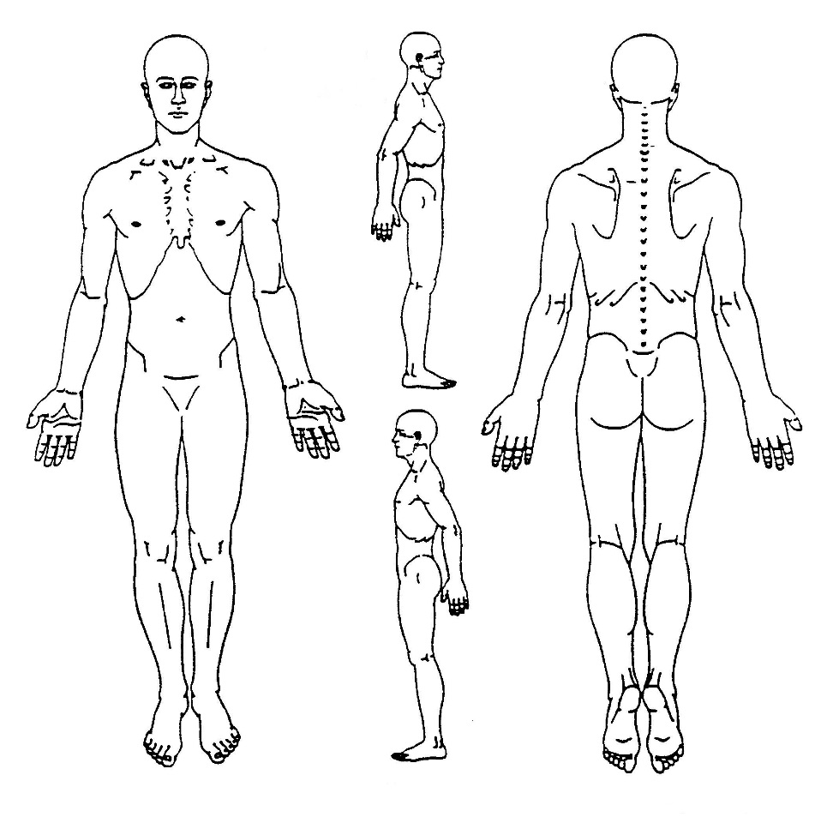

Source: http://www.wps.ac.nz
What makes the pain less?
What makes the pain worse?
What type of pain is it? (For example, stabbing, throbbing, dull ache.)
Is it constant, or does it come and go?
Is the pain relief you are currently receiving enough to make a real difference to your life?
Adverse events |  |  | Is the client experiencing any of the following symptoms?
 |  |  |  |  |  | None |  |  | Mild |  |  | Moderate |  |  | Severe
Nausea
Vomiting
Constipation (When were bowels last open?)
Itching
Mental cloudiness
Sweating
Fatigue
Drowsiness
Other:
_______________________________
Other:
_______________________________
Comments:

Action to be taken:

